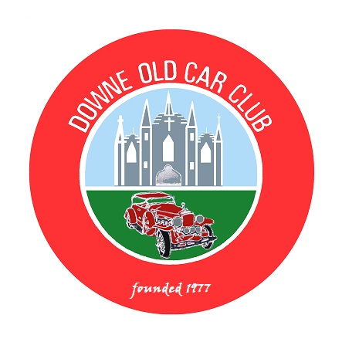
DOWNE OLD CAR CLUB
(Affiliated to the AOVC)

President: Billy Burrowes Chairperson: Brian Ward
Secretary: Eugene Morgan Treasurer: James Truesdale

St. Patrick’s Festival Vintage Vehicle Cavalcade and Static Display

Sunday 17th March 2019

Downe Old Car Club is organising the above named event in Downpatrick which is being sponsored by Newry, Mourne and Down District Council as part of its St. Patrick’s Festival.

The Cavalcade will assemble from 12 noon in the Car Park, Downpatrick Civic Centre, Downshire Estate, Ardglass Road, Downpatrick BT30 6RA (Old Downshire Hospital).
Roads in Downpatrick will be closed until 11:45am - Jimmy's 10K, Road Run is on from 9am.

The Cavalcade will commence at 1pm. making its way along Ardglass Road,
Edward Street, John Street, Irish Street and Market Street to the Static Display area in the Lidl Car Park. The main parade will carry on to the car park at Downpatrick Railway.

We will be ahead of the main parade, no bands will be in front of us.

Static Display until 3pm. (while we watch the main parade pass).

Cars, motorcycles and commercial vehicles registered before 31st December 1994 are welcome to take part.

This will be the 23rd year that the Downe Old Car Club has organised the Cavalcade.

Please Return Entry Form by: - Saturday 2nd March 2019 Contact Phone Number: - 0780 387 5754

(We will be operating on the Councils 11/1 )

Cut along line------------▲ (Please keep top section for your information) ▲--------Cut along line

DOCC: St. Patrick’s Day Cavalcade - Sunday 17th March 2019

Name of Entrant …………………………………………… Mobile Phone No. …………………………… .

Address …………………………………………………………………………………………………………

Name of Affiliated Club..............……………………………………………………………………………….

Vehicle: - Make…………………………..Model………………Year………….…Registration No……………

Declaration: - In consideration of this entry being accepted and me being permitted to take part in the above event, I declare that during the whole period of the drive my entry will be covered by insurance as required by law applicable and is valid for an event such as this. I confirm that the driver/s of any vehicle entered holds or has held and is not disqualified from holding or obtaining a licence to drive a vehicle of the appropriate class. I further agree to abide by regulations governing the event, with the directions given by the appointed marshals and with the decision of the Organising Committee on any matter.

Signature of Entrant………………………………………………………………… Date……………………………….....

This event is organised with the authority of the A.O.V.C. in N.I. Ltd. (On the Councils 11/1)

Detach and return by 2nd March 2019 to: - Mr. E. Morgan, 18 Edenvale, Crossgar. BT30 9PU. or scan and email to: - docc.secretary@aovc.co.uk

Tick to agree that the information above can be stored electronically and used to process this Entry and inform you of future events. This information will not be disclosed to any third parties. Tick here

Tick to agree that your name, town and vehicle details can be included in the list of
Entrants given out at the Event and in any Pre or Post event Publicity. Tick here

