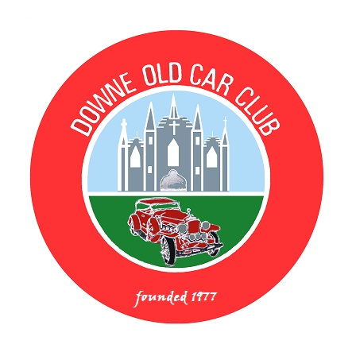
DOWNE OLD CAR CLUB
(Affiliated to AOVC)

President: Eugene Maguire Chairperson: Brian Ward
Secretary: Eugene Morgan Treasurer: James Truesdale.

Evening Run to Newcastle

Saturday 18th August 2021

We will meet on the Old Road behind Brennans Filling Station which is on the main Ballynahinch Newcastle Road from 18:30 for a 19:00 departure.

Route forms of the route will be given out on the night.

In Newcastle we can have a walk, Coffee or indeed buy Ice Cream or we can just hang around and have a bit of craic.

Please Detach and bring Entry Form with you on the night

Contact Phone Number: - 0780 387 5754

(Parades Commission Ref. No. PAR\89466)

Eligible Vehicles are only those registered on or before 31st December 1957

*************************************************************************

DOCC Evening Run to Newcastle - Thursday 18th August 2021

Name of Entrant…………………………………………………… Mobile Phone No. ……………………….

Address………………………………………………………………………………………………………….

Name of Affiliated Club………………………. .……………………………………………………………....

Vehicle: -

Make…………………..…..Model………………………Year………….…Registration No………………….

Declaration: - In consideration of this entry being accepted and me being permitted to take part in the above event, I declare that during the whole period of the drive my entry will be covered by insurance as required by law applicable and is valid for an event such as this. I confirm that the driver/s of any vehicle entered holds or has held and is not disqualified from holding or obtaining a licence to drive a vehicle of the appropriate class. I further agree to abide by regulations governing the event, with the directions given by the appointed marshals and with the decision of the Organising Committee on any matter.

Signature of Entrant………………………………………………………………………Date………………………………

This event is organised with the authority of the A.O.V.C. in N.I. Ltd. (Parades Commission Ref. No. PAR\ 89466)

Detach and bring with you to: - Mr. E. Morgan, 18 Edenvale, Crossgar. BT30 9PU. or scan and email to: - docc.secretary@aovc.co.uk

