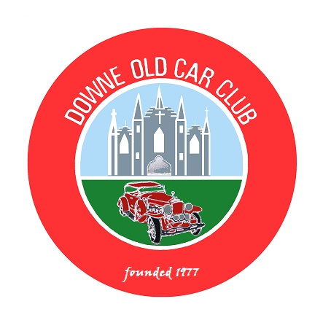
DOWNE OLD CAR CLUB
(Affiliated to AOVC)

President: Eugene Maguire Chairperson: Brian Ward
Secretary: Eugene Morgan Treasurer: James Truesdale.

Picnic Run to Groomsport - Saturday 21st August 2021

We will meet at the Ulster Flying Club Car Park, accessed from the Portaferry Road, Newtownards from 10.00am.

There is a good Restaurant on site – “Cloud 9”

We will leave from here at 11am. For a wee cross country drive to Groomsport where we will avail of our self provided picnic.

We are also free to dine at any of the local hostelries if we prefer.

About 2pm. we will have a coastal drive along the east Coast of the Peninsula towards Ballywalter, then across to Greyabbey and back towards Newtownards and Comber via the West Coast where we all disperse in a direction to suit our route home.

Please Detach and Return Entry Form by: - 14th August 2021

Contact Phone Number: - 0780 387 5754

(Parades Commission Ref. No. PAR\89468)

Eligible Vehicles are only those registered on or before 31st December 1957

*************************************************************************

DOCC Picnic Run to Groomsport - Saturday 21st August 2021

Name of Entrant……………………………………………………………… Mobile Phone No. ………………………………..

Address………………………………………………………………………………………………………………………………

Name of Affiliated Club……………………… Downe Old Car Club ……………………………………………………………..

Vehicle: - Make…………………………..Model……………………………Year………….…Registration No………………….

Declaration: - In consideration of this entry being accepted and me being permitted to take part in the above event, I declare that during the whole period of the drive my entry will be covered by insurance as required by law applicable and is valid for an event such as this. I confirm that the driver/s of any vehicle entered holds or has held and is not disqualified from holding or obtaining a licence to drive a vehicle of the appropriate class. I further agree to abide by regulations governing the event, with the directions given by the appointed marshals and with the decision of the Organising Committee on any matter.

Signature of Entrant………………………………………………………………………Date………………………………

This event is organised with the authority of the A.O.V.C. in N.I. Ltd. (Parades Commission Ref.. No. PAR\ 89468)

Detach and return by 14th August 2021 to: - Mr. E. Morgan, 18 Edenvale, Crossgar. BT30 9PU. or scan and email to: - docc.secretary@aovc.co.uk

