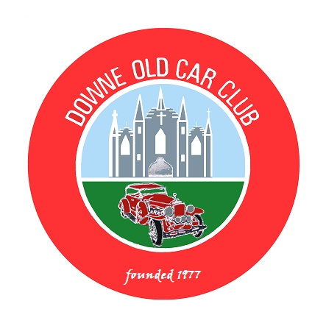
DOWNE OLD CAR CLUB
(Affiliated to AOVC)

President: Eugene Maguire Chairperson: Brian Ward
Secretary: Eugene Morgan Treasurer: James Truesdale.

End of Season & Memorial Run - Saturday 18th September 2021

We remember at our memorial run this year, Mr. Billy Burrowes, Mrs. Margaret Rodgers and Mr. Malachy Clendenning, members who have unfortunately died since our last memorial run. We are remembering 3 past members this time as we lost out on last years run because of Covid 19.

We hope to have someone from each family present to say a few words.

We will meet in the car park behind the Methodist Church on Lisburn Street, Ballynahinch at 10:30am. for a prompt 11am. departure.

We will drive to the Ulster Aviation Centre at the Maze, Lisburn, where we will partake of our self provided picnic. An indoor room is available for dining if the weather is inclement. This will be followed by a whistle-stop tour of the exhibits of which there are many.

We will be there from 12 noon to about 3pm.

We will then drive to “The Drumlins” Restaurant at the Temple Golf Club for our afternoon meal which will be served at 4pm.

Please Detach and Return Entry Form by: - 4th September 2021

Remember! you can enter the run without attending the dinner if you wish.

There will be NO Ballot this year.

Contact Phone Number: - 0780 387 5754

(Parades Commission Ref . No. PAR\90241)

Eligible Vehicles are only those registered on or before 31st December 1957

(Please keep this section for your information)

I have just inherited another problem with the End of Season and Memorial Run in that I have to provide the Restaurant with a seating plan of members and their ordered meals so that each table gets served before moving on to the next. I will try and figure members companions out from past experience when I find out who is going.
You will be given a table number that you must sit at on the day. Thank You.

Please get your details in by the beginning of September.

End of Season and Memorial Run

Saturday 18th September 2021

Main Courses : Number

Mature Irish Roast Beef with Y/S Pudding - - - - - - - - - - - - - - - ->

Pan Fried Breast of Chicken served with Mash & Vegetables - - - >

Grilled Fillet of Salmon served with Mash and Vegetables - - - - - >

Desserts :

Fresh Fruit Pavlova - - - - - - - - - - - - - - - - - - - - - - - - - - ->

Strawberry Cheesecake - - - - - - - - - - - - - - - - - - - - - - - - ->

Trio of Ice Cream - - - - - - - - - - - - - -- - - - - - - - - - - - - - - ->

Fresh Fruit Salad - - - - - - - - - - - - - - - - -- - - - - - - - - - - - - >

Number for Meal _____ at £20 / head = £_____________

*** Cheques made payable to Downe Old Car Club

***(Payment must accompany entry form to facilitate ordering of meals as all meals have to be pre paid by the Club to the Restaurant at the time of ordering. Thank you)

Please make known any special dietary requirements.

*************************************************************************

DOCC End of Season and Memorial Run - Saturday 18th September 2021

Name of Entrant……………………………………………………………… Mobile Phone No. ………………………………..

Address………………………………………………………………………………………………………………………………

Name of Affiliated Club……………………… Downe Old Car Club ……………………………………………………………..

Vehicle: - Make…………………………..Model……………………………Year………….…Registration No………………….

Declaration: - In consideration of this entry being accepted and me being permitted to take part in the above event, I declare that during the whole period of the drive my entry will be covered by insurance as required by law applicable and is valid for an event such as this. I confirm that the driver/s of any vehicle entered holds or has held and is not disqualified from holding or obtaining a licence to drive a vehicle of the appropriate class. I further agree to abide by regulations governing the event, with the directions given by the appointed marshals and with the decision of the Organising Committee on any matter.

Signature of Entrant………………………………………………………………………Date……………………………….....

This event is organised with the authority of the A.O.V.C. in N.I. Ltd. (Parades Commission Ref.. No. PAR\ 90241)

Detach and return by 4th September 2021 to: - Mr. E. Morgan, 18 Edenvale, Crossgar. BT30 9PU. or scan and email to: - docc.secretary@aovc.co.uk

