
Club Run
Sunday 28th August 2022
OPEN TO ALL MEMBERS OF AOVC CLUBS, CLASSIC CAR ENTHUSIASTS AND FRIENDS

We shall be starting this club run from Moe’s grill carpark The Junction shopping complex, Antrim, Meeting at 1.30 for a 2.00pm move off, heading northwest past Toomebridge stopping at Creative Gardens Galgorm Castle for a tea/coffee and maybe some shopping around 3,00pm, then heading northeast via Broughshane, Deerfin then south passing Parkgate, ending our run at the Ballymac Hotel with an optional meal around 5.30pm. A Route map and menu shall be supplied at the start of the run the meal shall cost £20.00 per person. We hope to see you at this Club Run, remember to confirm your entry by Email, Post, WhatsApp or text message to John Jnr. Please share this club run with your friends.

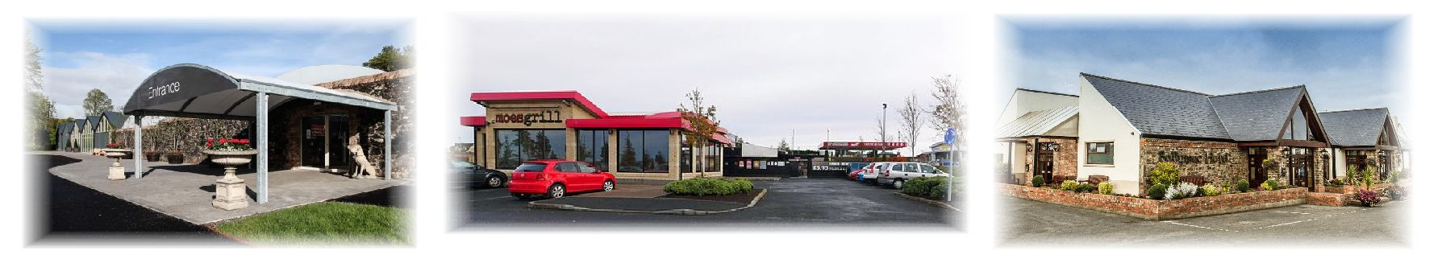
------------------------------------------------------------------------------------------------------------------------------------------
Club Run 28th August 2020
Name | Make
Address | Model
 | Reg No.
Post Code | Reg date
Mobile | Email
Reply to: Triumph Club NI. John Scott Jnr. 64 Stoneyford Rd Lisburn BT28 3SR
Text/Tel: 078 3366 8908 – Email: info@triumphclubni.co.uk______
Declaration; In consideration of this entry being accepted and my being permitted to take part in the above event, I declare that during the whole period of the drive, my entry will be covered by insurance as required by the relevant law applicable and is valid for an event such as this. I confirm that the driver(s) of any vehicle entered holds or has held and is not disqualified from holding or obtaining a licence to drive a vehicle of the appropriate class. I further agree to abide by regulations governing the event, with the directions given by appointed marshals and with the decision of the organising committee on any matter _____________________________________________________________________________________________________________________

SIGNED…………………………………………….…………............... Dated……………………………
If you wish to receive information of our future events, please tick this box
to allow us to store your details.
To see our privacy statement, visit: www.triumphclubni.co.uk___

ORGANISED UNDER THE AUTHORITY OF THE AOVC in NI LTD
Further copies of this form can be printed from the Internet at www.aovc.co.uk and www.triumphclubni.co.uk

