
TRIUMPH CLUB N.I.
Club Run
In Memory of Joe
Sunday 8th June 2025

Everyone is welcome to attend our Club run in memory of our good friend Joe Cushnahan. We shall be starting the run at the Ballymac Hotel, Lisburn from 1.30pm for a 2.00pm move off. Our route shall take us over some of the places Joe enjoyed with the Club, we shall be stopping around 3,00pm for a break with time to catch up for chat and a coffee. Around 4.00pm we shall be heading back to the Ballymac Hotel to end our day with an optional meal at around 5.30/6.00pm @ £30.00 per person. Menus shall be provided at the start of the run.
There is no entry fee but on the day a donation to charity would be appreciated.
This Club run is open to all classic cars and enthusiast and friends.
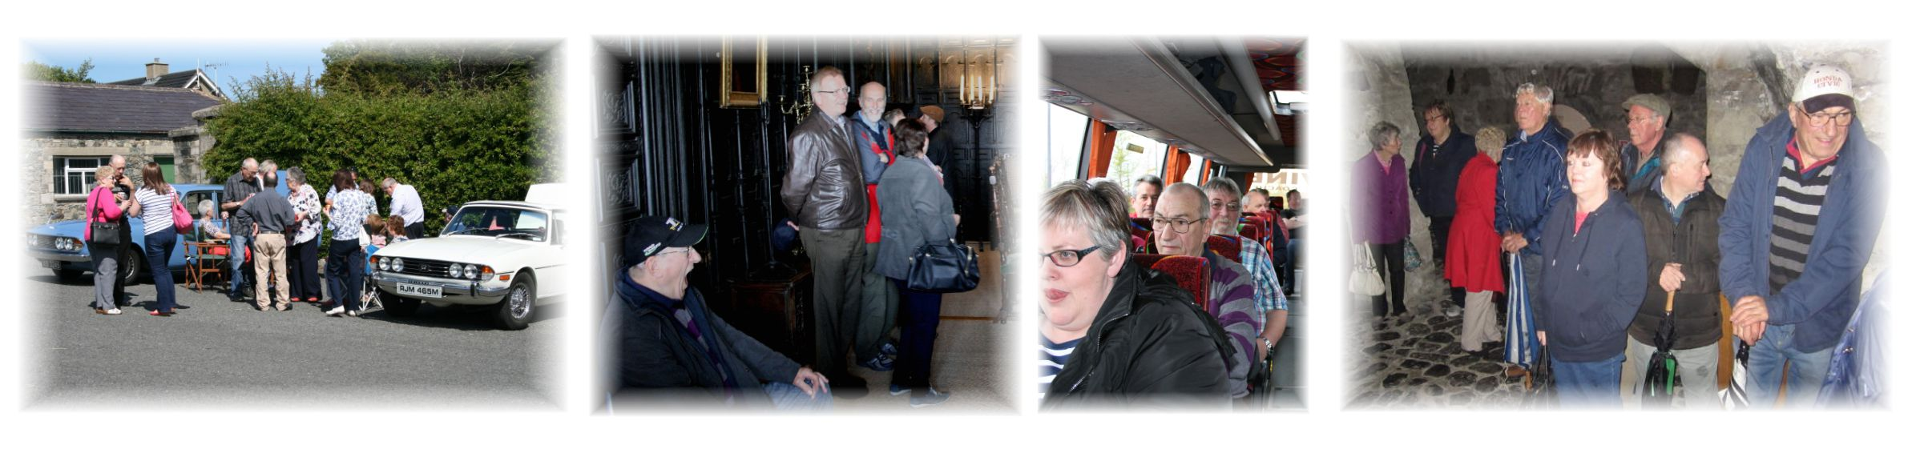
---------------------------------------------------------------------------------------------------------------------------------------
Club Run 8th June 2025

Name ………........................................................ Make ….........................................................

Address ....…...................................................... Model …........................................................

………………….................................................... Reg no. …...........................................……..

…………………...................BT ………................ Reg date .......................................................

Mobile …................................................. Email ….....................................................................

Please return completed entry form to: John Scott Jnr. 64 Stoneyford Road, Lisburn. BT28 3SR
Or by email to: info@triumphclubni.co.uk Or by a WhatsApp photo to 078 3366 8908
____________________________________________________________________________________
Declaration; In consideration of this entry being accepted and my being permitted to take part in the above event, I declare that during the whole period of the drive, my entry will be covered by insurance as required by the relevant law applicable and is valid for an event such as this. I confirm that the driver(s) of any vehicle entered holds or has held and is not disqualified from holding or obtaining a licence to drive a vehicle of the appropriate class. I further agree to abide by regulations governing the event, with the directions given by appointed marshals and with the decision of the organising committee on any matter. _______________________________________________________________________

SIGNED………………………………………………………...... Dated………………………………
If you wish to receive information of our future events, please tick this box to allow us to store your details. To see our privacy statement, visit: www.triumphclubni.co.uk
ORGANISED UNDER THE AUTHORITY OF THE AOVC in NI LTD
Further copies of this form can be printed from the Internet at www.aovc.co.uk and www.triumphclubni.co.uk

