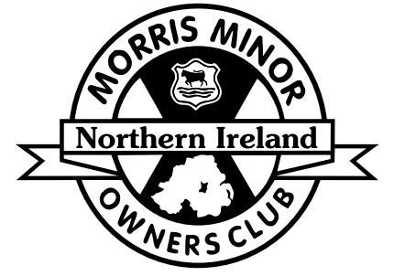
Bangor Luke’s Point Carpark Seacliff Road, Static Display
Friday 19th July 2019

The Morris Minor Owners Club would like to invite you to our Classic Vehicle static display at Luke’s Point Carpark, Seacliff Road, Bangor on the 19th July 2019 @ 18:30 to 21:30. All cars are to arrive no later than 19:15.

All completed entry slips should be returned to Ian Drakeley, 31 Newtown Crescent, Newtownards, BT23 7GP or email drax.mmoc@aovc.co.uk no later than Saturday 13th July 2019. All entrants vehicles must have been first registered 1989 or older.

------------------------------------------------------------------------Please keep the top half for your records

I wish to book my car for the MMOC static display at Luke’s Point Carpark, Seacliff Road, Bangor

Name: ________________________________

Address: _____________________________________________________________

_____________________________________________________________________

Telephone Number: _____________________ email ___________________________

Make_____________ Model____________ Year_______ Reg No ____________

The information above will be stored securely electronically to process this Entry. This will not be disclosed to any third parties. Further details on our Privacy Policy are available from http://mmoc-ni.co.uk/privacy-policy. Tick the box opposite to give consent to send you Entry Forms for future events. | Tick Here
Tick to give consent that your Name, Town and vehicle details may be used for any pre/post event publicity and on the list of entrants given out at the event. Tick here | Tick Here

Run organised under the authority of the AOVC in N.I. Ltd.
Declaration: In consideration of this entry being accepted and my being permitted to take part in the above
event, I declare that during the whole period of the drive my entry will be covered by insurance as required
by the relevant law applicable and is valid for an event such as this. I confirm that the drivers of any vehicle
entered holds or has held and is not disqualified from holding or obtaining a license to drive a vehicle of the
appropriate class. I further agree to abide by regulations governing the event, with the directions given by
appointed marshals and with the decision of the Organising Committee on any matter.

I Confirm the year of first registration of the vehicle entered above is correct

Signed __________________________________ Dated _______________

