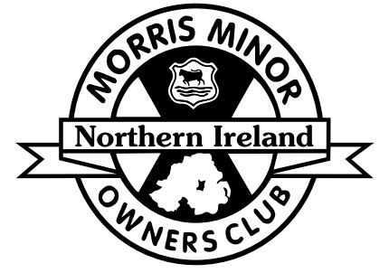
Morris Minor Owners Club
Regional Rally
Saturday 18th August 2018
2018 is a very special year of the Morris Minor as we celebrate 70 years since the first car went into production. This year we are having a slightly different format for our regional rally and we would encourage as many old cars as possible to attend. This year we will be meeting for a mainly static display in the Village of the Ulster Folk and Transport museum in Cultra. We will leave in cavalcade at 4pm for an optional meal at the Auld House in Moneyreagh. Entrance for the static display and the Meal must be pre-booked. Entrance into the museum for one car, a driver and one passenger is £10. This will give access to both parts of the museum. Any additional passengers will cost £9 per person. The optional meal at the Auld house will consist of a two-course meal with tea or coffee at £15 person. Children’s meals will be £6.
If you wish to attend, please enclose your cheque and the slip below to: Stephen Gordon, 13 Sandhill Park, Belfast, BT5 6DR, 07925060730. All vehicle entries must have been registered before 31st December 1989. Closing date for entries is 10th August 2018
------------------------------- keep the top half for your records-------------------------------
I/we wish to take part in the MMOC Regional Rally on 18th August 2018
Title _________ First Name ____________________________ Surname ____________________________________
Address________________________________________________________________________________________________________________________________________________________________________________________
Postcode __________________________________________ Telephone ____________________________________
Email _______________________________________________________@__________________________________
Vehicle Make___________________________________ Model __________________________ Year ____________
Meal options (main and dessert)
Please indicate numbers from the list below. Number of Adults at £15 ____
Roast Beef, Yorkshire Pudding and Gravy _______
Peppered Chicken, Tobacco Onions and pepper sauce _______
Oven Roasted Salmon served with white wine cream sauce _______
Contact us for vegetarian options
Pavlova _______
Cheesecake _______
Selection of Ice Cream _______
Kids Meal (Primary School age) Number of Kids Meal at £6 _____
Museum Entry for car, driver and one passenger £10
Additional Passengers at £9 each ______
Cheque enclosed payable to MMOC for £___________
The information above will be stored securely electronically to process this Entry. This will not be disclosed to any third parties. Further details on our Privacy Policy are available from www.mmoc-ni.co.uk/privacy-policy. Tick the box below to give consent to send you Entry Forms for future events.
Tick here
Tick to give consent that your Name, Town and vehicle details may be used for any pre/post event publicity and on the list of entrants given out at the event. Tick here

Run Organised under the Authority of the AOVC in N.I. Ltd.
Declaration : In consideration of this entry being accepted and my being permitted to take part in the above event, I declare that during the whole period of the display and drive my entry will be covered by insurance as required by the relevant law applicable and is valid for an event such as this. I confirm that the driver(s) of any vehicle entered holds or has held and is not disqualified from holding or obtaining a licence to drive a vehicle of the appropriate class. I further agree to abide by regulations governing the event, with the directions given by appointed marshals and with the decision of the Organising Committee on any matter. I confirm the year of first registration of the vehicle entered above is correct.

Signature Of Driver _______________________________________ Date_________

