TRIUMPH CLUB N.I.
Transport Museum Run
Sunday 12th June 2022

The Club Run to the Transport Museum, Cultra. Starting from the Ballymac Hotel with tea, coffee & scones.
Meeting from 12.00noon for a 1.00pm move off for a short 20mile drive arriving to the museum.by 1.45pm, with parking on the grounds. We’ll have plenty of time at the museum to view the exhibits and have a tea/coffee. Regrouping 4.00pm for a 4.30pm move off for another short drive through the Castlereagh Hills, heading to Carryduff . The entry cost for the Museum Run will be £10.00 per person collected at the start of the run at the Ballymac Hotel.
We shall end our day with an optional meal at Eight South Restaurant, Carryduff around 5.30pm @ £20.00 per person. Menus shall be provided at the start of the run.

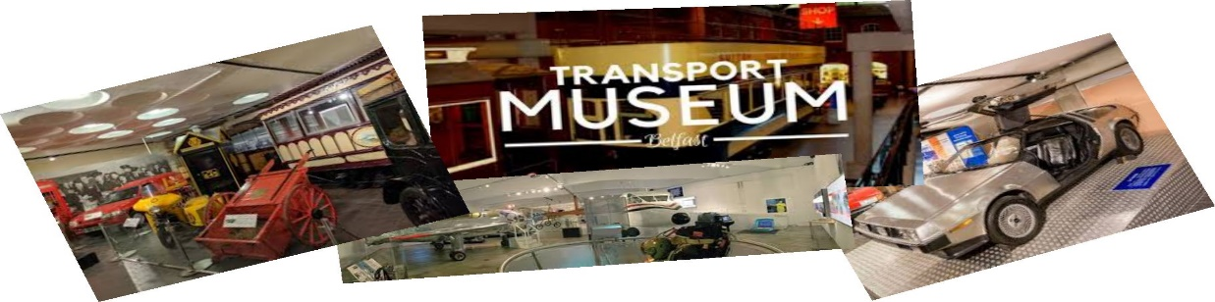
---------------------------------------------------------------------------------------------------------------------------------------
Transport Run 12th June 2022

Name ………........................................................ Make ….........................................................

Address ....…...................................................... Model …........................................................

………………….................................................... Reg no. …...........................................……..

…………………...................BT ………................ Reg date .......................................................

Mobile …................................................. Email ….....................................................................
Please return completed entry form to:John Scott Jnr. 64 Stoneyford Road, Lisburn. BT28 3SR
Or by email to: info@triumphclubni.co.uk Or by a WhatsApp photo to 078 3366 8908
____________________________________________________________________________________
Declaration; In consideration of this entry being accepted and my being permitted to take part in the above event, I declare that during the whole period of the drive, my entry will be covered by insurance as required by the relevant law applicable and is valid for an event such as this. I confirm that the driver(s) of any vehicle entered holds or has held and is not disqualified from holding or obtaining a licence to drive a vehicle of the appropriate class. I further agree to abide by regulations governing the event, with the directions given by appointed marshals and with the decision of the organising committee on any matter___________________________________________________________________________________________________________
.
SIGNED………………………………………………………...... Dated………………………………
If you wish to receive information of our future events, please tick this box to allow usto store your details. To see our privacy statement, visit: www.triumphclubni.co.uk
ORGANISED UNDER THE AUTHORITY OF THE AOVC in NI LTD
Further copies of this form can be printed from the Internet at www.aovc.co.uk and www.triumphclubni.co.uk

